|  |
| --- |
| **Support SOP for Product X** |
| IT Department |

Document Control

This document is located within the AB Company SharePoint

****Revision History****

|  |  |  |  |  |
| --- | --- | --- | --- | --- |
| Date | Version | Status | Author | Summary of Changes |
| 21/02/2025 | 0.1 | Draft | Technical Writer | First Draft |
| 15/05/2025 | 0.2 | Draft | Technical Writer | Updated due to change of support desk |
| 01/06/2025 | 1 | Final | Head of IT | Approved |

Approvals Record

This document requires the following approvals:

|  |  |  |  |
| --- | --- | --- | --- |
| Name | Title | Signature | Date |
| Name | Head of IT | X | 01/06/2025 |
|  |  |  |  |
|  |  |  |  |
|  |  |  |  |

Reference Documents

|  |  |  |  |
| --- | --- | --- | --- |
| Document Name | Location | Version | Author |
| Doc 1 | SharePoint link | 1 | Technical Writer |
| Doc 2 | SharePoint link | 1 | Technical Writer |
| Doc 3 | SharePoint link | 1 | Technical Writer |
| Doc 4 | SharePoint link | 1 | Technical Writer |

Contents

1. Purpose 3

2. Documentation 3

3. General Procedure 3

4. Scheduled Support 3

5. Unscheduled Support 4

5.1. Hazard Log Evaluation for compliance purposes 4

7. Appendix 1 – Flow Chart for Support Work 6

8. Appendix 2 – Using a Second Email Address 7

9. Appendix 3 – Editing an Email 8

Purpose

This document sets out the process of the support process for Product X. The flowchart outlining the support SOP can be found in Appendix 1

**Note:** This document is a generic Standard Operating Procedure (SOP) template created for illustrative and operational purposes. It is not intended to reference or represent any specific individual, organization, or proprietary process. Any resemblance to actual companies, systems, or personnel is purely coincidental.

Documentation

All documentation mentioned in this SOP can be found using the Product X link on the AB Company main SharePoint Page.

General Procedure

If a successful tender is accepted for Product X which includes a support contract, then the following procedure will apply.

* Send out a draft Service Level Agreement (SLA) with the quotation.
* Upon acceptance of the quote, work will commence on tailoring Product X.
* Once Product X goes live, send out a final SLA completing the following fields:
* Client Name.
* Start Date.
* Number of months that the contract will run for.
* No of support days.

Scheduled Support

To ensure that all software and hardware is maintained with the latest firmware or software patches and updates are applied in a timely manner, agree a monthly patching window with the client so any released updates to Windows Server, SQL Server and .NET can be tested, and applied without undue delay.

Use the [AB Company support](mailto:support@abcompany.co.uk) email address for all support correspondence with the client. See Appendix 2.

* Log the work on Azure Dev Ops.
* Open the Change Request Support Log to record the support update – please note it is important that the sections relating to the Hazard log are completed.
* Follow the communication channels laid out in the communication plan to liaise with the client.
* Ensure the work is completed in accordance with the SLA reporting any issues to the Head of Products to ensure that the lines of communication are kept up to date.
* Update the Change Request Log.
* Close the DevOps ticket.

Unscheduled Support

* In the support agreement, clients are requested to send an email to [AB Company](mailto:support@abcompany.co.uk). If the request did not come in via the shared mail box, then forward the work request to the shared folder.
* Move the email to the Help folder
* Log the work on Azure Dev Ops. Ensure you include on the notes an @reference so the current Head of Product x is notified and is aware of the request.
* Edit the email to add the DevOps ticket number. See Appendix 3 for instructions.
* Check whether the work is covered by the current SLA agreement.
* If not then notifiy the client, request a PO, update DevOps, and stop work until the PO is received.
* If yes, open the Change Request Support Log to record the support request – please note it is important that the sections relating to the Hazard log are completed. Details are outlined below, as it is more likely that this will be applicable to unscheduled requests than routine maintenance which should not affect the overall hazard posed by the app.
* Contact the AB Company Quality Rep who will organise a meeting with the Product X team and the Head of IT to review the additional hazards.
* Complete the requested work, liaising with the client and updating devops and the change request log as applicable.
* Update Azure DevOps and the change log with additional information, where applicable.
* Follow the communication channels laid out in the communication plan to communicate with the client. Update DevOps with any communications.
* Ensure the work is completed in accordance with the SLA reporting any issues to the Head of Products to ensure that the lines of communication are kept up to date.
* Upon completion of the work
  + Complete any remaining fields in the Change Request Log.
  + Close down the DevOps ticket.
  + Move the email from the Data Products share mailbox folder into the completed folder.

Hazard Log Evaluation for compliance purposes

Notify the Head of Products of the proposed change so that an evaluation can be made to see whether the change raises any additional hazards which need to be added to the Hazard Log.

If a possible hazard (s) is identified:

* Add as a user story on Devops so it can be monitored and tickets raised against all actions for monitoring purposes.
* Update the Change Request and Incident Log to state that a hazard review is required.
* Then contact the Clinical Safety Officer to arrange a meeting between Head of Products, the Product X developer, the AB Company Quality Rep, and the Head of IT.
* Update the Hazard Log with the date of the meeting.
* At the Hazard Review Meeting, the change can be evaluated, assessed, and recorded if deemed an additional hazard.
* If additional documentation is required to mitigate the hazard ensure that this is recorded on DevOps, so it can be monitored. The task should be assigned to the Head of Product X until someone else is able to complete the task.
* Update the Hazard Log with a brief description of the outcome of the meeting.
* Once all paperwork has been completed change the Review of the Hazard Log completed column to Yes.
* The Quality Rep must also update the next Quality Meeting to ensure that the review is included in the minutes of the meeting. The update should include:

The date and time of the meeting

Meeting attendees

Brief description of the review

The outcome of the meeting.

Any actions arising from the meeting including updates to the Hazard log or additional paperwork required.

This will remain an open action at the Quality Meeting until the AB Company Quality Rep confirms that all paperwork/actions relating to the identified hazard are completed.

Appendix 1 – Flow Chart for Support Work

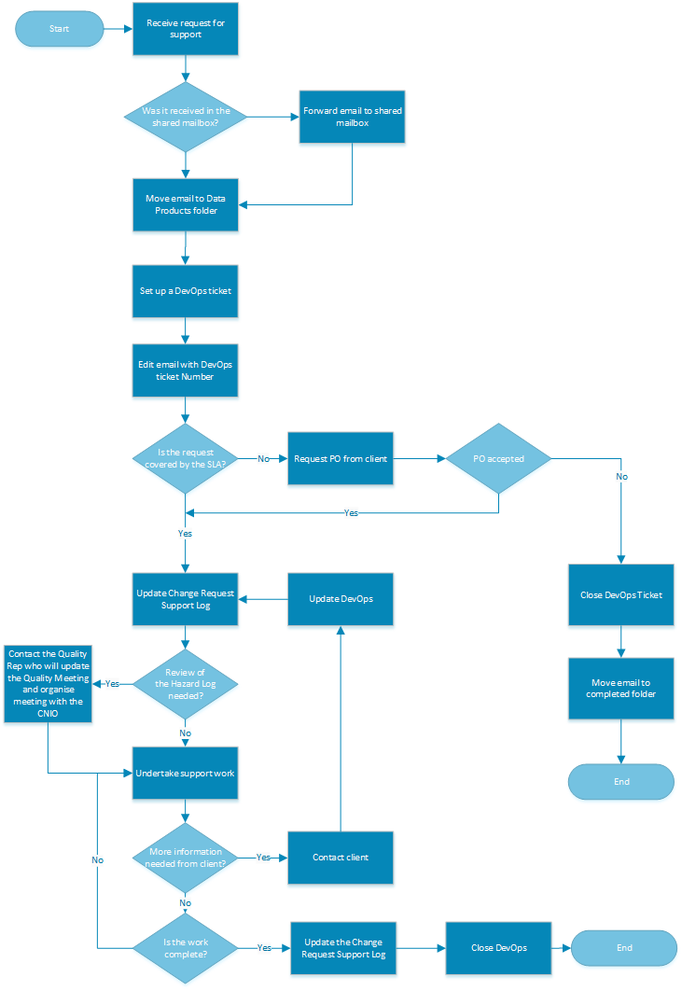

Appendix 2 – Using a Second Email Address

This procedure describes how to show a second email address so you can send messages from the support email account.

* Open Outlook
* Select New Email

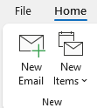

* Select the Options Tab and select From icon. An additional line will appear in your new message.

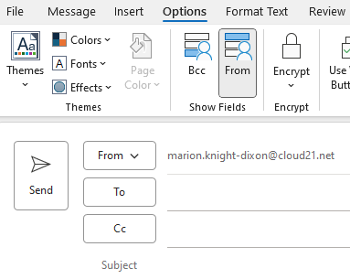

* To find the support email address, select the From drop down arrow and select other email address.

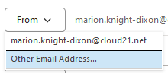

* Type [support@abcompany.co.uk](mailto:support@abcompany.co.uk) in the dialog box or select from to search for the email address.

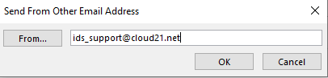

* Select OK to the email address in the From line.
* For future messages, just select the drop down arrow by From to select the required email.address.

 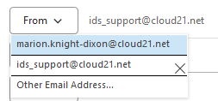

Appendix 3 – Editing an Email

* Open Outlook and scroll down to the Support email account.

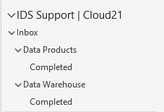

* Open the email – this does not work if you read in preview mode.

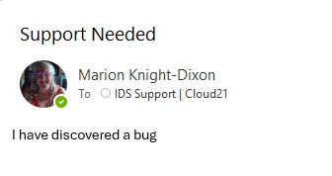

* Select the message tab > Select Actions > Edit Message.

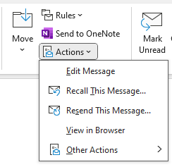

* Select the top fo the email and type **DevOps number: xxxx.** Change the text colour to red for ease of viewing.

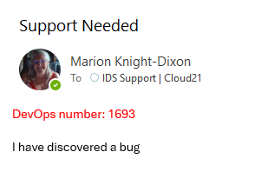

* Select save

Screen print showing the save icon.